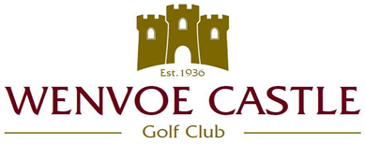

Code of Conduct for all Members of Wenvoe Castle Golf Club

- Expected behaviour.
  - Treat everyone with respect.
  - Respect fellow members of the club by using good practices and acceptable behaviours.
  - Be mindful of your surroundings and of other club users.

- Examples of unacceptable behaviour
  - Promoting or participating in harassment, bullying, discrimination, or intimidation on-site, online, and/or on social media.
  - Verbal, written, or other forms of abuse of any attendee, speaker, volunteer, staff member, service provider, or other guest.
  - Examples of abuse include, but are not limited to, verbal comments related to gender, sexual orientation, disability, physical appearance, body size, race, religion, national origin, inappropriate use of nudity and/or sexual images in public spaces or in presentations.
  - Threatening or stalking in-person or online.
  - Disruption or disallowing participation by others.
  - Failure to follow meeting protocol.
  - Physical or verbal abuse, including attacks on ideas vs. respectful, disagreeing dialogue.
  - Use of social or mainstream media to target individual actions of participants in a way that could harm their privacy or professional status or open them to slander or libel.

- Consequences and reporting unacceptable behaviour.

- Anyone requested to stop unacceptable behaviour is expected to comply immediately.

- Anyone violating the Code of Conduct in a meeting may be removed from that meeting. Unacceptable behaviour may result in bans from future meetings or other sanctions, depending on the specifics.

- If any club member experiences or is a witness to behaviour that constitutes a breach of this code should report the incident to a member of the Management Committee immediately.

Acknowledgement and agreement to abide by this code of conduct is a condition of membership of Wenvoe Castle Golf Club.

Other Relevant Policies of WCGC: Social Media Policy

