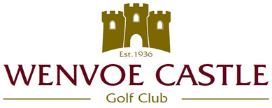

MIXED OPEN MEETING

SUNDAY 14 AUGUST 2022

(18 HOLES GREENSOME STABLEFORD)

Minimum of 6 Drives each

Stroke Allowance
Lower handicap X 0.6
plus, Higher handicap X 0.4
of course, handicap

To enter you must be a member of an affiliated Golf Club
Handicap Certificate Required

PRIZES
1st and 2nd Visitors
1st and 2nd Wenvoe Castle Members

PLEASE SEE THE WEBSITE FOR DRESS CODE

STARTING TIMES FROM 9.00am

ENTRANCE FEE £28.00 PER COUPLE

(Inclusive of Ball Sweep)

ENTRIES

www.wenvoecastlegolfclub.co.uk
OR
Club Secretary on 02920 594371 (Option 2)

