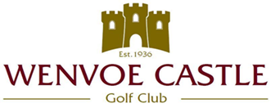

LADIES 9 HOLE GOLF AND COFFEE MORNING

MONDAY 6 SEPTEMBER 2021

Singles competition playing in groups of 3
95% Reduction off Course Handicap

Starting Times from 9.00 am - 11.30 am

Entrance Fee £6 per person
(Inclusive of Refreshments)

Stalls and Raffle

Entries in Writing ONLY enclosing a S.A.E., the entrance fees, name of the club, names of the players and a telephone contact number.

CHEQUES PAYABLE TO
WENVOE CASTLE GOLF CLUB (LADIES)

LADIES HON.SECRETARY,
MRS. WENDY MOTTON,
87, PORT ROAD EAST, BARRY, CF62 9PX
EMAIL: wmotton@btinternet.com

