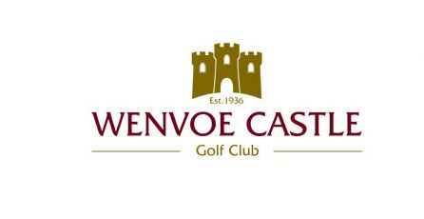

Wenvoe Castle Golf Club
Men’s Open Day
Saturday 28th August 2021
Individual Stableford
Full Handicap Index Allowance
Prizes for 1st 2nd 3rd and 4th
Prizes for Nearest the Pin & Longest Drive
ACTIVE HANDICAP INDEX REQUIRED/CDH NUMBER ESSENTIAL
Catering available throughout the day
Starting times from 8am
Presentation approx. 7.30pm

Entry £18 per person (optional sweeps)

Bookings taken by telephone, email or online
Please contact the Secretary
029 20594371 (option 1)
Email wenvoecastle@btconnect.com
Bookings taken online at
www.wenvoecastlegolfclub.co.uk
Book a tee time
Wenvoe, Cardiff CF5 6BE

